**Project Design Phase-II**

**Technology Stack (Architecture & Stack)**

|  |  |
| --- | --- |
| Date | 03 October 2022 |
| Team ID | B4-4M6E |
| Project Name | Data Analytics for hospital health care data |
| Maximum Marks | 4 Marks |



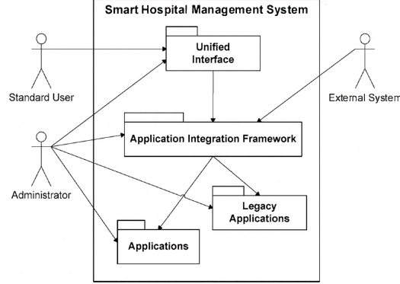

|  |  |  |  |
| --- | --- | --- | --- |
| **S.No** | **Component** | **Description** | **Technology** |
|  | **User Interface** | **How user interacts with application e.g.**  **Web UI, Mobile App, Chatbot etc.** | **HTML, CSS, JavaScript / Angular Js** |
|  | **Application Logic-1** | **Logic for a process in the application** | **Java / Python** |
|  | **Application Logic-2** | **Logic for a process in the application** | **IBM Watson STT service** |
|  | **Application Logic-3** | **Logic for a process in the application** | **IBM Watson Assistant** |
|  | **Database** | **Data Type, Configurations etc.** | **MySQL, NoSQL, etc.** |
|  | **Cloud Database** | **Database Service on Cloud** | **,IBM Cloudant etc.** |
|  | **File Storage** | **File storage requirements** | **IBM Block Storage or Other Storage Service or Local Filesystem** |
|  | **External API-1** | **Purpose of External API used in the application** | **IBM Weather API, etc.** |
|  | **External API-2** | **Purpose of External API used in the application** | **Aadhar API, etc.** |
|  | **Machine Learning Model** | **Purpose of Machine Learning Model** | **Object Recognition Model, etc.** |
|  | **Infrastructure (Server / Cloud)** | **Application Deployment on Local System / Cloud**  **Local Server Configuration:**  **Cloud Server Configuration :** | **Kubernetes,** |

**Table-2: Application Characteristics:**

| **S.No** | **Characteristics** | **Description** | **Technology** |
| --- | --- | --- | --- |
|  | **Open-Source Frameworks** | **List the open-source frameworks used** | **Technology of Opensource framework** |
|  | **Security Implementations** | **List all the security / access controls implemented, use of firewalls etc.** | **e.g. SHA Encryptions** |
|  | **Scalable Architecture** | **Justify the scalability of architecture (3 – tier, Micro-services)** | **Technology used** |
|  | **Availability** | **Justify the availability of application (e.g. use of load balancers, distributed servers etc.)** | **Technology used** |
|  | **Performance** | **Design consideration for the performance of the application (e.g use of load balancers,distributed servers etc)** | **Technology used** |